**Proposal for the sighting of the Step IV control and power racks in the RF area.**

*Roy Preece, Tim Hayler, Ian Mullacrane, Jason Tarrant, Mike Courthold and Alan Grant*

**Introduction**

The MICE Cooling Channel magnets were designed without yokes, to avoid compromising beam optics, and to avoid complicating their construction; thus magnetic shielding walls were required to limit the fringe field to the MICE Hall. Lengthy studies showed that the majority of the fringe field could be contained by means of two parallel walls of good-quality magnetic steel. However, this approach has limitations, although we are able to reduce the fields to acceptable levels on the far side of the shield walls, we are left with extremely high fields between the shield walls. The non-yoke approach resulting in these high fields creates significant functional and safety issues with magnetically-sensitive equipment and ferrous objects. The stray fields are likely to interfere with equipment such as compressors, vacuum pumps and electronics racks. To prevent damage to these items we are planning a combination of local shielding and relocation. This report sets out to illustrate the various options and their implications for managing stray fields at MICE Step IV.

**MICE infrastructure components affected by stray magnetic fields**

All components within the magnetic shielding walls, and slightly beyond, will be subject to very high magnetic fields. It is possible to individually shield items with a combination of Mu-metal and Iron or relocate the items elsewhere. However, both local shielding and relocation have cost implications. It would seem sensible to move the sensitive components as far from the stray fields as practical, to reduce the risk of failure and the cost of local shielding, this is advantageous for all MICE steps and not just for Step IV. We do also need to respect the schedule and getting step IV running sooner rather than later needs to be part of the decision making process. To understand the extent of the problem, and determine what the options are, we have begun to list the sensitive items:

* There is no place where the field will be less than 50 Gauss
* Most of the region will experience fields in excess of 500 Gauss
* The stray field will affect numerous infrastructure components, particularly:
  + Turbo-pumps (fields > 5 Gauss) (due to eddy-current heating)
  + Rotary or scroll pumps, and motors generally
  + Transformers, relays, circuit-breakers (MCBs and RCDs)
  + Electro-magnetic valves, and proximity detectors (which use Hall effect)
  + Cryo-cooler heads and their compressors
  + Computer hard-disks, and other magnetic media
  + Vacuum gauges

An inventory of sensitive equipment in the MICE hall is currently being done. The current list of sensitive components can be found at <http://micewww.pp.rl.ac.uk/projects/magnetic-shielding>. It is essential that system owners check their systems thoroughly for magnetically-sensitive components, avoiding/replacing them where possible, and bringing all remaining sensitive components to the attention of the Magnet Group before installation in the MICE Hall.

**RF area description (TH, JT)**

The area proposed to sight the racks that will experience very low levels of field is behind the North shielding wall, the planned location for the RF amplifiers that will be used during the Steps V and IV schemes.

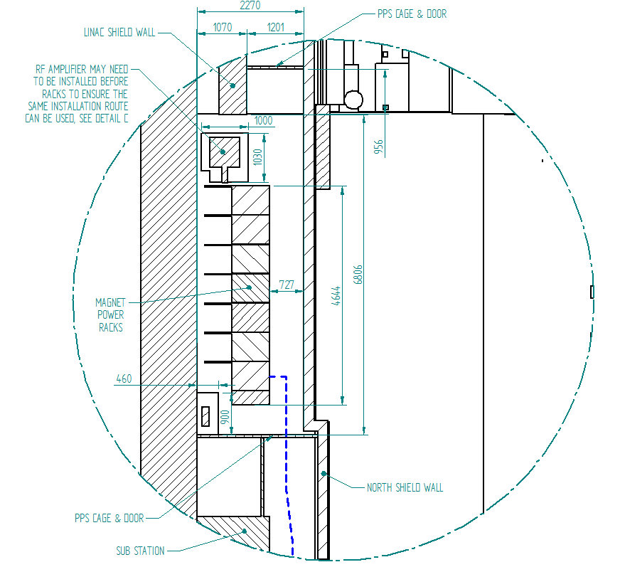

A method for getting the racks into position would be from the west end, past the substations, as indicated by the blue dotted line. A second method for installing would be to remove some of the deck plates of the messanine above the RF area and drop the racks into position using the crane. Using this method the racks can be installed fully loaded with equipment, each rack is equipped with lifting points. The route for using the crane for installation would be to lift onto the North Messanine with the large overhead crane and then to move into position using the smaller 1 tone beam crane that extends to the wall.

**Proposed layout (IM,TH, JT)**

Please see attached drawings – 204_70016 sheets 10 and 11 for the layout in the RF area with the cable management routing included.

**Services required for the area**

**Water (TH)**

The only equipment requiring water services will be the power dump circuits for the Spectrometer Solenoids. This will be a small amount of work and can be included to other packages of work.

**Power and Instrumentation (IM)**

Power for the rack position behind the North wall can come from the power boards adjacent to the RF area, the boards that will eventually feed the RF amplifiers that will ultimately be sited in this position. Cable management will be required to serve the racks, overhead and the power feed for the magnets from the supplies will extend under the false floor. Instrumentation will follow the same route from the magnets under the false floor to the control racks. The power supplies for the Spectrometer Solenoid requires a power feed from a transformer currently located in the trench, investigation is required to confirm operation of the transformer in the generated field.

**Field map with equipment (MC)**

***Using the proposed rack layout calculate the field behind the North wall***

**Cost estimates**

* 1. **Water and air services (TH)**

No cost for moving water or compressed air supplies will be associated with the rack position behind the North shield wall

* 1. **Power and Instrumentation routing (IM)**

|  |  |  |
| --- | --- | --- |
| Item | Capital (£K) | STFC Staff (£K) |
| Manufacture of Hall Control Rack | 15 | 5 |
| Re-Work on Magnet Power supply rack | 3 | 5 |
| Installation of Cable Management Systems | 5 | 2 |
| Procurement of Magnet Cables | 9 | 1 |
| Specify & Procure Inst Cables/Connectors | 8 | 2 |
| Network control Re-Installation | 3 | 1 |
| Purchase additional 19” Racks (Steel) | 4 | 0.5 |
| Design/Drawing re-work as required | 3 | 0.5 |
| PPS Changes | 3 | 0.5 |
| Unknown moves of other racks | 10 | 3 |
|  | ***63*** | ***20.5*** |

**Capability to install RF amplifier 1 (AG, RP)**

To adhere to the TIARA funding body requirements and schedule the first RF amplifier currently being tested at the Daresbury laboratory must be installed into the MICE hall and operation verified by ****. This is a requirement to gain further funding for the remainder of the RF amplifiers, a further three units.

