**Proposal for relocating the Step IV Compressors to the west wall**

*Roy Preece, Tim Hayler, Ian Mullacrane, Jason Tarrant, Mike Courthold and Alan Grant*

**Introduction**

The MICE Cooling Channel magnets and spectrometer solenoids were designed without yokes, to avoid compromising beam optics, and to avoid complicating their construction; thus magnetic shielding walls were required to limit the fringe field outside the MICE Hall. Items such as the RF amplifiers that were identified as sensitive to magnetic fields were sited behind the magnetic shield walls. Lengthy studies showed that the majority of the fringe field could be contained by means of two parallel walls of good-quality magnetic steel. However, this approach has limitations, although we are able to reduce the fields to acceptable levels on the far side of the shield walls, we are left with extremely high fields between the shield walls. The non-yoke approach resulting in these high fields creates significant functional and safety issues with magnetically-sensitive equipment and ferrous objects. The stray fields are likely to interfere with equipment such as compressors, vacuum pumps and electronics racks. To prevent damage to these items we are planning a combination of local shielding and relocation. This report defines the location for the compressors that serve the cryocoolers at MICE Step IV. The scheme is likely to be suitable for Steps V and VI.

**MICE infrastructure components affected by stray magnetic fields**

All the components within the magnetic shielding walls, and slightly beyond, will be subject to very high magnetic fields. To reduce the field strength experienced by the components we propose either to shield them with a combination of Mu-metal and Iron or to relocate them elsewhere. However, both local shielding and relocation have cost implications. To reduce the risk of failure and the cost of local shielding it is necessary to move the sensitive components as far from the stray fields as practical, this is advantageous for all MICE steps. As part of the decision making process we do also need to respect the schedule, having to create a lot of extra infrastructure will take significant time and capital. To understand the extent of the problem, and determine what are options are, we have begun to list the sensitive items:

* There is no place where the field will be less than 50 Gauss;
* Most of the region will experience fields in excess of 500 Gauss;
* The stray field will affect numerous infrastructure components, particularly:
  + Turbo-pumps (fields > 5 Gauss) (due to eddy-current heating) ;
  + Rotary or scroll pumps, and motors generally;
  + Transformers, relays, circuit-breakers (MCBs and RCDs);
  + Electro-magnetic valves, and proximity detectors (which use Hall effect);
  + Cryo-cooler heads and their compressors;
  + Computer hard-disks, and other magnetic media;
  + Vacuum gauges.

An inventory of sensitive equipment in the MICE hall is currently being done. The current list of sensitive components can be found at <http://micewww.pp.rl.ac.uk/projects/magnetic-shielding>. It is essential that system owners check their systems thoroughly for magnetically-sensitive components, avoiding/replacing them where possible, and bringing all remaining sensitive components to the attention of the Magnet Group before installation in the MICE Hall.

**Proposed layout (IM,TH, JT)**

For the Step IV scheme, 19 compressors, 13 two stage and 4 single stage, are required for operation of the 2 Spectrometer Solenoids (10 Two stage + 2 Single), the single Focus Coil (3 Two stage) and the Tracker detectors (4 two-stage). To ensure the compressors experience the minimum field possible the farthest point away from the cooling channel is at the West wall, downstream of the beam.

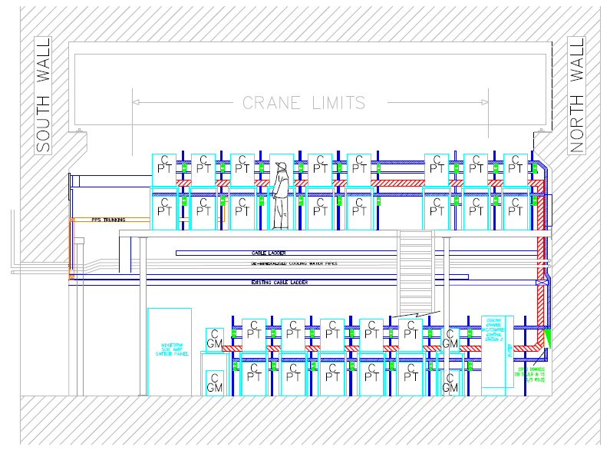

Figure 1. Proposed layout for the step IV and later step VI compressors at the west end of the MICE hall, view looking east to west.

**Services required for the area**

**Water**

*Move water services from the South wall – Move the pumping system from the trench*

The water services for the step IV compressors and those for subsequent MICE steps need to be moved from the south shield to the west wall. Some of the fittings can be used again but there will be additional costs with the new arrangement.

It follows that the plant equipment, providing the water cooling for the compressors, would benefit from being moved from the trench to the west wall or somewhere nearby. The move would provide simpler pipe routing, serviceability and remove the plant equipment, power and control from the magnetic fields in the trench area. Suggested new locations for the plant equipment would be the west wall, outside and to the west of the MICE main door or the ISIS plant room.

**Power and Instrumentation**

We will need to move all the power sockets from the South wall and re-locate them to the West wall. We require a rack for monitoring and controlling the output from the water flow meters, the temperature and pressure of the compressors, and the plant equipment. The power distribution boards will need to be moved to the North West corner.

The timing of the installation work is very important; it is likely that the cables from the compressors to the cold heads and high pressure hoses will travel under a false floor that will be linked to the new north mezzanine stairway. Because of the space limitations in the MICE Hall this new infrastructure may need to be temporarily removed for the installation of the magnets, this would be difficult if the services are interconnected with the infrastructure. A proposed location for the compressors, power distribution boards and control rack are shown in figure 2.

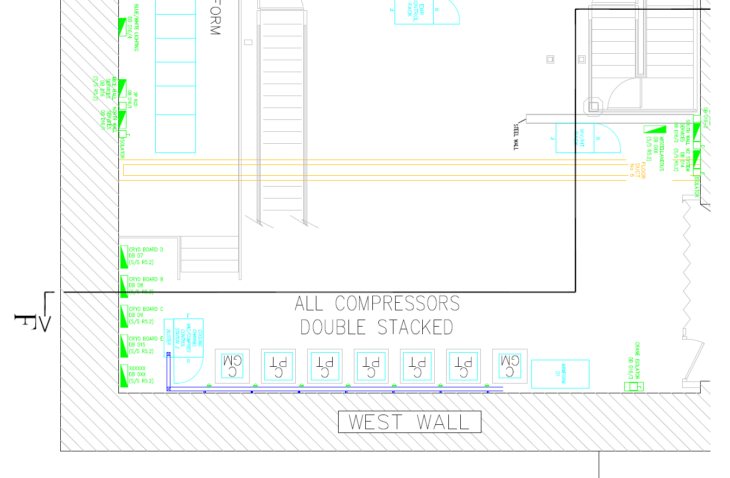

Figure 2. Plan view of the ground floor compressor locations against the west wall.

**Support and structural**

The 19 compressors required for step IV will be positioned on the ground floor, at the west end of the MICE hall, as shown in figure 1. Because of the limited space available it will be necessary to double stack the compressors whilst maintaining easy access to all the services. We do already have enough compressor stands to double stack the compressors for step IV. Power sockets, flow meters, water inlet and outlet pipes for individual compressors will be distributed along the west wall accordingly.

As part of the compressor move it will be necessary to develop the existing infrastructure. The proposed area for the new compressor arrangement is presently taken up by the north mezzanine stairway, this stairway will have to be removed and an alternative stairway installed. The corresponding PPS gate and fencing will also need moving.

High pressure hoses travelling from the compressors to the cooling channel will need designated routes and supporting structures to carry them either over ground or underground.

**Field map with equipment (MC)**

***Using the proposed compressor layout calculate the field at the West wall?***

**Cost estimates**

1. **Water and air services (TH JG)**

***Cost for the relocation of the cooling water services and pumping systems from the trench (JG, TH)***

***How much of the old system can we use again? (JG, TH)***

***What is the new position of the plant equipment? (JG, TH)***

***a) West wall (south or North West corner)***

***b) ISIS plant room***

***c) Outside and to the west of the main door***

***Breakdown of costs? (JG, TH)***

Ball park figure 15k

1. **Support and structural (JT,TH,GB)**

|  |  |  |  |  |  |
| --- | --- | --- | --- | --- | --- |
| **Task** | **Duration** | **Men** | **Man Days** | **Comments** | **Material costs £** |
|  |  |  |  |  |  |
| **Total costs** |  |  |  |  |  |
|  |  |  | 2.5k | OPUS, structural engineers contract |  |
|  |  |  | 12.5k | Regal fixed price contract |  |

1. **Power and Instrumentation routing (IM, AG)**

|  |  |  |  |  |  |
| --- | --- | --- | --- | --- | --- |
| **Task** | **Duration** | **Men** | **Man Days** | **Comments** | **Material costs £** |
| Replace D13 with Redspot | 1 | 2 | 2 |  | 800 |
| Remove temporary feeders to 5.4 |  |  | 0 | Done by Building projects group |  |
| Remove and salvage all compressor isolators etc. | 4 | 2 | 8 |  |  |
| Modify cable tray riser | 3 | 2 | 6 | After south Mez modifications | 300 |
| Remove and relocate Compressor Dist Boards | 15 | 2 | 30 | Position to be agreed. Scaffolding req’d | 200 |
| Reposition D18 RF Board | 5 | 2 | 10 | Position to be agreed | 150 |
| Strip out PS on existing stair West Wall | 3 | 2 | 6 |  |  |
| PS signs & PS door entry key box | 5 | 2 | 10 |  | 250 |
| Clear out workshop area | 2 | 2 | 4 |  |  |
|  |  |  |  |  |  |
| **New Stairs installed** |  |  |  |  |  |
| Install Power Distribution for 19 compressors | 10 | 2 | 20 | Fixed to concrete wall | 250 |
| Manufacture compressor/vac control rack | 20 | 1 | 20 | Contract out | 1500 |
| Modify localised lighting | 2 | 2 | 4 |  | 250 |
| Install modified PPS | 10 | 2 | 20 |  | 260 |
|  |  |  |  |  |  |
|  |  |  |  |  |  |
| **New Rack Position** |  |  |  |  |  |
| Manufacture & install localised tray work | 5 | 2 | 10 |  | 200 |
| Cold head interconnecting cables | 5 | 2 | 10 | Follows hose route? Provided by others |  |
|  |  |  |  |  |  |
| Hall lighting? |  |  |  |  |  |
| 208v transformer? |  |  |  |  |  |
| Water Panels in Trench? |  |  |  |  |  |
| Extend North Wall shielding to protect Sub-Station? |  |  |  |  |  |
|  |  |  |  |  |  |
| **Total costs** |  |  |  |  |  |
|  |  |  | 160 x £200/day |  | 4160 |
| Total |  |  | £32K |  | £4.2K |

1. **Helium Lines (JT)**

***What is the current proposed route for the He compressor lines from the compressors to the magnets? (JT)***

***We will need an additional false floor, trench or overhead support for cabling and He lines. (JT)***

**Time estimates**

1. **Water services**
2. **Power and Instrumentation**
3. **Helium Lines**
4. **Support and structural**