Stellar Evolution

Stellar evolution is the process by which stars are formed, live and die (“evolution” is a bit of a misnomer—“stellar lifecycles” would be more appropriate). These notes provide a bit more detail than the lectures, for those of you who find this style easier to digest. Unless otherwise specified, the pictures come from the Australia Telescope outreach site,  
 <http://outreach.atnf.csiro.au/education/senior/astrophysics/stellarevolutiontop.html> ,  
which is also a very useful resource for this subject.

In the lectures, we started with main-sequence stars, which was a logical progression from the previous lecture on the Hertzsprung-Russell diagram, but here I’ll work in the conventional order from star formation to stellar death.

# Star Formation

Stars form when interstellar gas collapses under its own gravity. In order to do this the gas has to be cool and dense—the appropriate locations are **giant molecular clouds**. The image on the right[1] shows the Cygnus X molecular cloud complex imaged in an emission line of 13CO. The regions of highest density (red) would be those most prone to collapse.

Gas clouds can collapse for a number of reasons, including

* pressure from the shock wave created by a supernova explosion (as core-collapse supernovae are themselves young objects, arising from massive, short-lived stars, this basically means that one star-formation event can trigger others nearby);
* compression from the **density wave** of a “grand design” spiral arm (see later in the course)—this effect is responsible for the young stars that line the arms of spiral galaxies;
* gravitational perturbations from nearby objects;
* turbulence within the cloud itself.

Generally, the initial collapse involves a fairly large, massive region of molecular gas, which will subsequently fragment as the collapse progresses. Therefore, **most stars form in clusters or associations** (an association is like a cluster, but is not gravitationally bound and so its stars will disperse over time). The Sun is currently a **field star**, not part of a cluster, but it was probably born as part of a cluster or association that has since dispersed.

During the initial stages of collapse, the gas cloud is still quite transparent, so it radiates away the energy gained from loss of gravitational potential energy, and doesn’t increase in temperature very much. The collapse is therefore rather rapid, and the density increases quickly. Eventually the cloud becomes opaque enough to trap some of the radiation, increasing its internal pressure and temperature, and slowing the collapse.

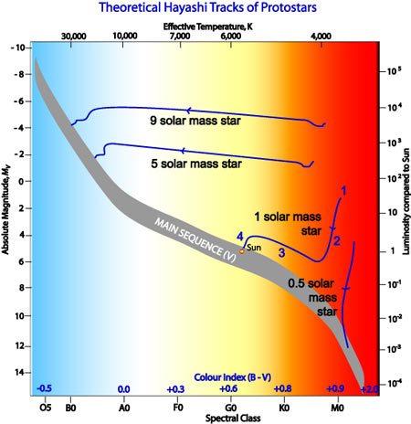Evolutionary tracks for pre-main-sequence stars of various masses are shown in the HR diagram on the right. The key stages are labelled 1-4 on the Sun’s track.

1. The rapid collapse phase has ended, and the Sun is a slowly contracting pre-main-sequence star. Its surface temperature is just under 4000 K, but it is very large, so it’s substantially more luminous than it will be on the main sequence.
2. As contraction proceeds, the young star initially remains at about the same surface temperature, but drops in size and therefore in luminosity. This is called the **Hayashi track** (after theoretical astro­physicist Chushiro Hayashi). During this phase the star is fully convective (all its heat transport is done by convection).
3. As the interior of the star heats up, its material becomes less opaque, allowing heat transport by radiation (at least in the core). This changes the structure of the star, and instead of contracting at constant surface temperature it begins to heat up, moving on to the **Henyey track** (after Louis Henyey).
4. Finally, hydrogen fusion turns on, and the star joins the main sequence.

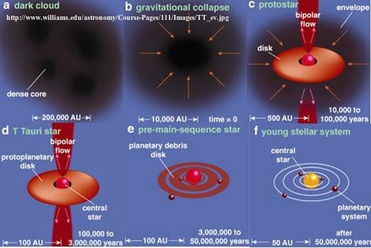Note that low-mass stars reach the main sequence while still on the convective Hayashi track, and in contrast high-mass stars spend almost all their pre-main-sequence lives on the Henyey track. The time spent in pre-main-sequence evolution decreases dramatically with increasing mass, from 108 years for a star of 0.5 solar masses to <105 years for stars of 15 solar masses.

The figure on the left summarises the various stages in the formation of a solar-type star.

Summary of stages of star formation

## Observations of Protostars and Pre-Main-Sequence Stars

There is a classification scheme for “Young Stellar Objects” based on the slope of their spectra in the infra-red region. There are exact numerical boundaries, beyond the scope of this course, but the outline of the classification is shown in the following table.

|  |  |  |  |  |
| --- | --- | --- | --- | --- |
| Class | Spectrum | Physical properties | Observational characteristics | Type of star |
| 0 | — | *M*env > *M*star > *M*disc | No optical or near-IR emission | young protostar |
| I | rising in mid-IR | *M*star > *M*env ~ *M*disc | Obscured in optical | protostar |
| FS | flat in mid-IR |  | intermediate between I and II |  |
| II | falling, but excess over blackbody | *M*disc/*M*star ~ 1%, *M*env ~ 0 | Accreting disc; Hα line and UV emission | T Tauri star |
| III | no IR excess | *M*disc/*M*star << 1%, *M*env ~ 0 | Passive disc; little accretion | weak-lined  T Tauri star |

In this table, *M*env is the mass of the envelope of gas and dust surrounding the young star, and *M*disc is the mass of the circumstellar disc. Hα is a spectral line of hydrogen: Hα emission is a sign of the presence of ionised hydrogen. Heavily obscured, very young objects (Class 0) aren’t really recognisable as stars, but can be observed in the millimetre region of the electromagnetic spectrum; Class I and FS objects are usually studied in the infra-red, while T Tauri stars can be observed in the optical but are usually better studied in the near infra-red (the region of the infra-red closest to optical wavelengths).

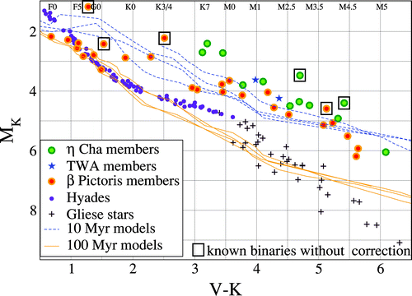The plot on the right[2] shows young stars near the Sun, compared to the older stars of the Hyades cluster and the Gliese catalogue of nearby stars. These stars are of order 10 Myr old, so somewhat beyond the T Tauri stage though not yet on the main sequence. (The ones with squares round them are known binaries, so their brightness is overesti­mated: they should be moved down by about 0.75 magnitudes.) The more massive (i.e. bluer) members of the β Pictoris association have already reached the main sequence, but the less massive ones further to the right have not—this confirms that less massive objects evolve more slowly in this stage as well as on the main sequence.

T Tauri stars are now very well-studied objects in all wavelengths: their active atmospheres emit in X-rays and ultra-violet, and their discs and outflows can be studied at radio wavelengths. Although details definitely remain to be understood, all the evidence is consistent with these being very young stars still contracting towards the main sequence.

# Main-Sequence Stars

Main-sequence stars fuse hydrogen to helium in their cores. The net reaction is

$$4 {}_{1}^{1}H→{}_{2}^{4}{He}+2e^{+}+2ν_{e},$$

but it’s not reasonable to expect a four-body collision (especially four positive particles which will all repel each other!), so in fact the reaction goes by a series of two-body collisions. There are two basic routes, the **pp chain** and the **CNO cycle**, both originally worked out by Hans Bethe in the late 1930s.

## The PP Chain

The main branch of the pp chain looks like this[3]:

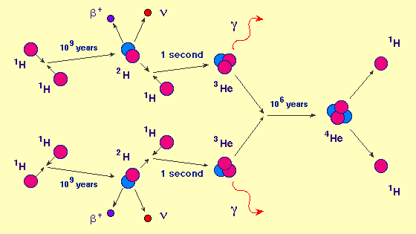

Note that the initial fusion of two protons is by far the most difficult step: this is because the kinetic energies of the protons are not *really* high enough to overcome the Coulomb barrier of their electrostatic repulsion, so the reaction only goes through **quantum mechanical tunnelling** (because of the Uncertainty Principle, it is possible for the protons to fuse “through” instead of “over” the barrier). The interaction of two nuclei of 3He turns out to be more proba­ble than that of 3He and a proton, so this is the main way in which 4He is made, even though it doesn’t seem to be the simplest way. As these are all random processes, the times shown are averages: although *on average* it takes two protons a billion years to fuse, this does not mean that the Sun was completely dark for the first billion years of its life—it just means that only one in a billion pairs of protons will fuse in any given year.

There are side branches of the pp chain which involve less probable reactions, e.g. the sequence 3He + 4He → 7Be + γ; 7Be + e− → 7Li + νe; 7Li + p → 2 4He (which accounts for about 1/6 of pp chain fusion in the Sun). These are important for solar neutrino experiments, because they produce more energetic neutrinos that are easier to detect, but they are not critical for our purposes.

## The CNO Cycle

The CNO cycle uses carbon-12 as a catalyst:

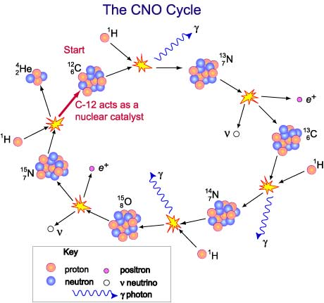

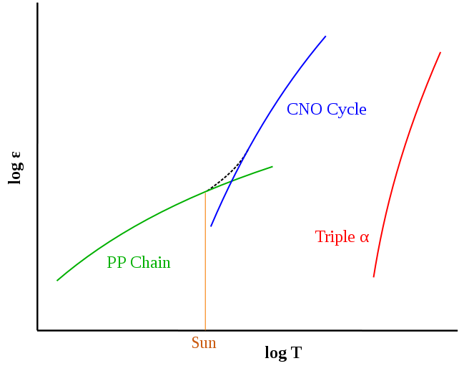If you count the number of protons added and the number of assorted particles emitted, you’ll see that this is the same net reaction, 4 1H → 4He + 2e+ + 2νe, and you get the carbon-12 back at the end. This reaction is very much more sensitive to temperature than the pp chain: the plot on the right (from Wikimedia Commons) shows a sketch of the amount of energy generated from pp chain hydrogen fusion, CNO cycle hydrogen fusion, and helium fusion, as a function of the *central* temperature of the star (note that the central temperature isn’t well represented by the surface temperature—an outwardly cool red supergiant may be fusing helium in its interior). Main-sequence stars above about 1.1 solar masses generate almost all their energy by the CNO cycle, but it accounts for only about 1% of the Sun’s energy output. It is worth noting that this situation must have been different for the very first generation of stars: since stars are needed to make the carbon in the first place, the first generation of stars *must* have used the pp chain even though theory suggests they would have been very massive. This would have had significant consequences for their interior structure.

# Leaving the Main Sequence

Stars remain relatively constant in luminosity and surface temperature during their time on the main sequence. This isn’t exact—you can see in the diagram on the next page that most stars become slightly more luminous and slightly cooler as they age (implying that they must get somewhat larger, as lower surface temperature plus increased total brightness implies increased surface area)—but it is a reasonable approximation. Eventually, however, the star will exhaust the hydrogen at its centre, and will therefore leave the main sequence.

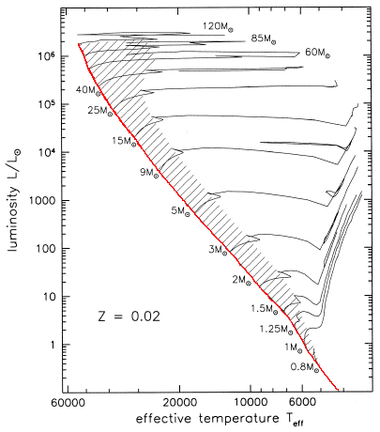

In the lectures, we focused on stars slightly more massive than the Sun, generating their energy by the CNO cycle. These stars have convective cores, which means that the core material is well mixed and all the core hydrogen runs out at once. As a consequence, the star leaves the main sequence *abruptly*—fusion stops altogether, internal pressure decreases, and the whole star shrinks under gravity, becoming smaller and hotter as gravitational potential energy is converted to heat. This is seen as the small jag to the left in the evolutionary tracks shown in the diagram[4] (the hatched area in the diagram represents the main sequence).

(solar heavy element content)

You may notice that the one-solar-mass track doesn’t have this reversal of direction at the end of the main sequence stage. That’s because in stars using the pp chain, the core is *radiative* rather than convective: the core material is not mixed, and the very centre of the core runs out of hydrogen while the regions further out in the core still have some left (because the tempera­ture, and hence the rate of fusion, is higher in the centre). The Sun will leave the main sequence gradually, not suddenly as is the case with more massive stars.

For the more massive stars, the shrinkage stops when the hydrogen just outside the core gets hot enough to fuse. (Note that this happens *long* before the core helium would fuse: you only need to heat the hydrogen just outside the core by a small amount to initiate fusion, whereas you’d have to heat the helium by at least a factor of 5.) When this happens, the resulting increase in internal pressure is more than enough to stop the star shrinking: instead the outer layers expand and cool, and the star becomes a **subgiant**.

Although the outer layers expand, the core does not (if anything, it contracts), and it also becomes more massive as the hydrogen-fusing shell produces more helium. The result is that the star never really becomes fully stable: it continues to expand and cool, initially at approximately constant luminosity (the hydrogen-fusing shell is becoming narrower, but also hotter, and the two effects nearly cancel out), but then at increasing luminosity as it moves from the subgiant branch to the red giant branch proper (the shell remains very narrow, but its increasing temperature now results in increasing luminosity).

You will notice that the post-main-sequence evolutionary tracks on this page almost mirror the pre-main-sequence tracks on page 2. This is not an accident: the near-vertical Hayashi track represents the limiting case for a fully convective star, and when the evolving subgiant star reaches this point the same physical limit comes into play. Just as in the pre-main-sequence case, massive stars evolve nearly horizontally, never reaching the convective limit, whereas low-mass stars have a horizontal segment and a near-vertical segment.

# Helium Fusion

The star’s evolution up the red giant branch is terminated when the core reaches the tempera­ture needed to initiate helium fusion (note that the star does *not* run out of hydrogen). Helium fusion is difficult both because of the higher charge of the helium nucleus (resulting in greater Coulomb repulsion) and because all mass 8 nuclei weigh *more* than two helium nuclei and are thus difficult to make (the colliding helium nuclei need to have enough kinetic energy to make up the extra mass, by *E* = *mc*2) and extremely unstable. The so-called **triple-alpha process** actually goes via an intermediate nucleus of 8Be (half-life 0.07×10−15 s!), and produces an excited state of the 12C nucleus whose energy is well matched to 8Be + 4He (this enhances the reaction rate, and explains why the reaction produces mostly 12C, instead of mostly 16O).

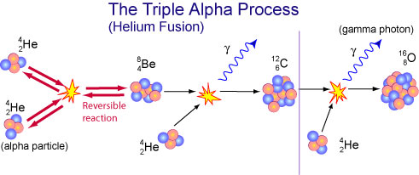

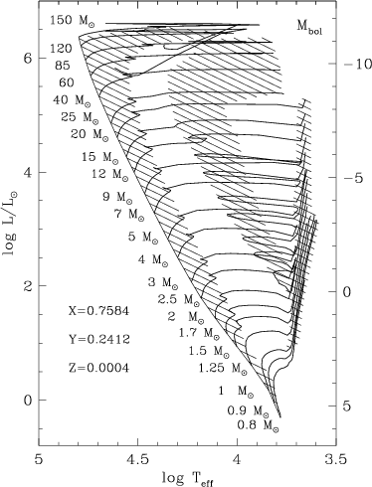The onset of helium fusion re-establishes a source of energy in the core of the star, and therefore stabilises its internal structure. The expansion of the outer envelope reverses, and the star settles down at a higher surface temperature, and usually a lower total luminosity, than it had at the tip of the red giant branch.

The image on the right[5] shows the evolutionary tracks for stars of a wide range of masses and very low heavy element content (1/50 of the Sun’s). The hatched regions are areas where the star spends a significant fraction of its life: on the left is the main sequence, as in the picture on the previous page, and on the right is the red giant branch. The hatched area in the middle represents core helium fusion. If you compare the two plots, you will see that the region of core helium fusion is further to the blue in this plot (low heavy element content) than it was in the previous plot (high heavy element content). In old clusters such as globular clusters, this is reflected in the form of the horizontal branch: short and red in clusters with relatively high heavy element content, long and extending to the blue in clusters low in heavy elements. The reason for this is that heavy elements are good at trapping energy radiated from the core—they have lots of electrons in lots of different energy levels, so they can absorb photons of many different wavelengths—and hence the outer layers of the star achieve a balance between pressure and gravity at a larger radius than they do if heavy elements are very rare, and radiation escapes easily.

Hydrogen fusion converts about 0.7% of the mass of the initial hydrogen into energy via *E* = *mc*2. Helium fusion is only about a tenth as efficient, converting about 0.07% of the mass of the helium into energy. In addition, as can be seen in the diagram, stars tend to be more luminous in the helium-burning phase than they are when fusing hydrogen. Helium fusion therefore lasts for a much shorter time than the preceding hydrogen fusion.

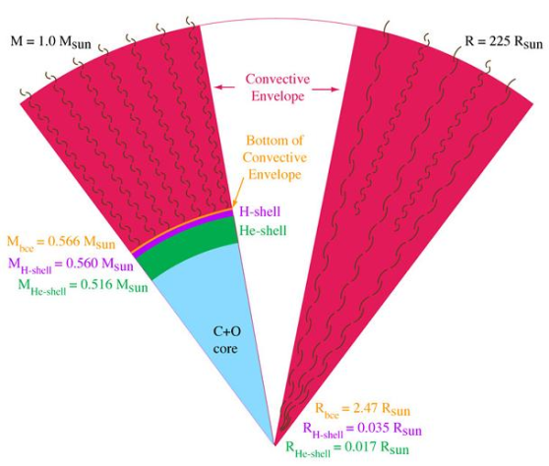When the core helium is exhausted, fusion moves to a shell around the inert carbon/oxygen core, and the star becomes a red giant again (this second ascent of the red giant branch is usually called the **asymptotic giant branch**, or AGB). In fact, two possible shell sources exist: the helium just outside the carbon core, and a hydrogen layer further out. The diagram on the right[6] shows the structure of an AGB star—the left-hand wedge has mass as the radial scale (which effectively magnifies the denser central regions), while that on the right has radius. The deep convective envelope is responsible for bringing newly synthesised s-process elements to the surface of the star.

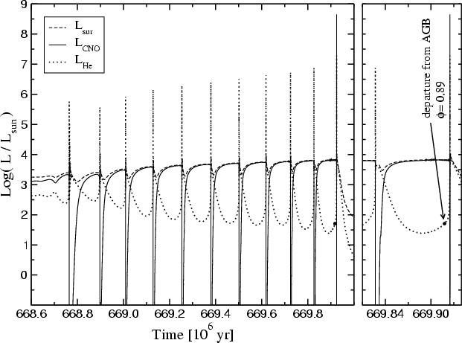Simulations indicate that initially the AGB star is powered by helium fusion, in a shell just outside the carbon core. The star evolves up the red giant branch much as it did during hydrogen shell fusion, with the carbon core becoming larger as more helium is fused. However, as the helium-fusing shell moves further from the centre, hydrogen fusion reignites above it. The two shells compete, producing **thermal pulses**. The star will expand and contract as the shells switch roles, executing **blue loops** on the HR diagram. The diagram on the right[7], which was calculated for a 2.7 solar mass star, shows how the hydrogen fusion (LCNO, solid line) and the helium fusion (LHe, dotted line) alternate during this stage.

With these rapid changes in interior structure, it is not entirely surprising that this is the period in which the star becomes very unstable and ejects a considerable part of its mass in a stellar wind, forming the gas cloud which will become a planetary nebula. The extremely hot carbon/oxygen core is then exposed as a young white dwarf.

[Note that although the vast majority of white dwarfs arise in this way and have carbon/oxygen cores, a few are pure helium, and an even smaller number are made of an oxygen/magnesium/ neon mixture. The helium white dwarfs are formed in close binaries as a consequence of mass transfer (see Vik Dhillon’s seminar); very-low-mass stars, which never get hot enough to fuse helium, will also eventually make helium white dwarfs, but their main-sequence lifetimes are trillions of years. The O-Mg-Ne white dwarfs arise from intermediate-mass stars which are just massive enough to initiate carbon fusion, but not quite massive enough to get to iron and go supernova. This is a narrow window, which is why we ignored it in the lectures, but there is evidence for the existence of this class of white dwarfs, at least in close binary systems.]

# Evolution of High Mass Stars

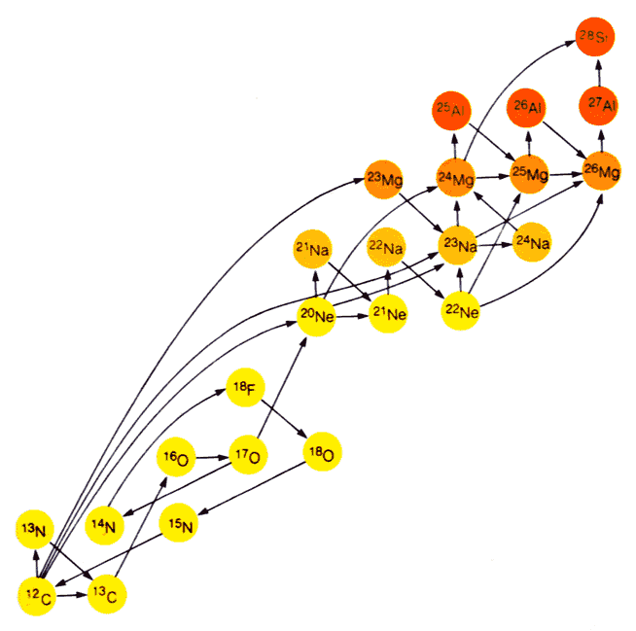High-mass stars have higher gravity than low-mass stars, and can therefore maintain higher core temperatures. They can sustain fusion of heavier elements. The fusion reactions get progressively more complicated as heavier elements are involved, because some of the nuclei formed by fusion subsequently decay, but essentially carbon fusion proceeds via  
an excited state of 24Mg and produces mostly 20Ne with some 23Na,  
neon fuses with helium to make magnesium and oxygen (since   
20Ne can be broken up into 16O + 4He if it is hit by a high-energy  
photon), and oxygen fusion produces phosphorus and silicon.  
(24Mg also fuses with helium to make silicon.)

Silicon burning proceeds mostly by the alpha process,  
i.e. by adding helium nuclei, rather than by direct  
fusion of two silicon nuclei (the Coulomb barrier  
for the latter process is very high). Either way,  
the process continues until a nucleus with   
mass 56 is formed (it’s actually unstable   
56Ni, which is an α-process isotope with   
equal numbers of protons and neutrons:  
this will subsequently decay to 56Fe).

Diagram from Michael Seeds, *Horizons*

Any further fusion will consume rather than generate energy, as *A* = 56 is the peak of the nuclear binding energy curve. Therefore, when the nickel/iron core gets heavy enough to collapse under its own gravity, it is not rescued by the ignition of another fusion process: instead, the collapse continues, increasing the temperature of the core until the newly formed elements are dissociated into a “soup” of protons, neutrons and electrons. Eventually it becomes energetically favourable to combine protons and electrons to make neutrons, p + e− → n + νe. This process is usually impossible because of energy conservation—the total mass of proton plus electron is less than the mass of the neutron—but in these extreme conditions it will proceed because it allows the star to shrink (owing to the Pauli Exclusion Principle, electrons take up far more room than protons and neutrons, so eliminating the electrons allows the collapsing core to lose gravitational potential energy). The collapsing outer layers of the star fall on to the extremely rigid surface of the newly formed neutron star, bounce off and, aided by the neutrinos released by the ultra-hot core, explode as a supernova.

Unfortunately, the last supernova seen in our Galaxy occurred in 1604. (A later one, which produced the supernova remnant Cassiopeia A, was heavily obscured by dust and seems not to have been observed, although some astronomers believe that the then Astronomer Royal, John Flamsteed, saw it in 1680 as a faint star which he catalogued as “3 Cassiopeiae”. 3 Cas definitely doesn’t exist, but although it is *close* to the position of Cas A, it isn’t *exactly* at that position, and the difference is many times Flamsteed’s usual observational errors. The experts on historical supernovae, Stephenson and Green (*JHA* **36** (2005) 217), reject the identification and suggest that instead Flamsteed mixed up the coordinates of two stars that do exist, producing the entry for 3 Cas as a result of this mistake.) Although supernovae can be observed relatively easily in other galaxies—this is one of the areas of astronomy where amateurs quite often make important contributions—the stars that produce them can’t, so it is difficult to test the theoretical predictions. SN 1987A, seen to explode in the Large Magellanic Cloud in February 1987, was definitely the massive blue supergiant Sanduleak 69 −202 before it blew up, but until recently that was the only supernova progenitor positively identified. Since then, however, a few more typical core-collapse supernovae (so-called Type II-P supernovae) in nearby galaxies have been identified as the explosions of red supergiants of about 8-16 solar masses, which is pretty much what we would predict. (The progenitor of the recent supernova SN 2011fe, in the very nearby galaxy M101, has not been identified, but as this was a Type Ia supernova arising from the explosion of a white dwarf in a binary system, its progenitor would not have been very bright.)

# Very High Mass Stars

Very high mass stars are never very stable, even on the main sequence: their extremely high luminosity creates a great deal of radiation pressure, which can cause mass loss even in this stage. These stars evolve to become **Wolf-Rayet stars**, very hot blue stars characterised by an emission-line spectrum (showing that they are surrounded by hot low-density gas—their ejected atmospheres). When they fuse heavy elements, they may collapse straight to a black hole with no intervening supernova (the black hole forms so fast that there’s no surface for the outer layers to bounce off), or in extreme cases they may explode in an unusual type of super­nova called a **pair-instability supernova**, caused by runaway production of e+e− pairs when the star’s core temperature exceeds 1010 K. Theory suggests that a pair-instability supernova can occur when the star’s initial mass is more than 130 solar masses. In a pair-instability super­nova, the entire star is consumed in the explosion, and no black hole or neutron star is formed. The unusually bright supernova SN 2007bi is suspected of having been a pair-instability supernova.

Sketch summarising stellar evolution for different masses, from Chandra website. From top: pair-instability supernova; direct collapse from Wolf-Rayet stage to black hole; supernova explosion of blue supergiant forming black hole; supernova explosion of red supergiant (or blue supergiant after mass ejection) forming neutron star; red giant forming planetary nebula and white dwarf; direct collapse of red dwarf to white dwarf (after trillions of years); gradual contraction and cooling of brown dwarf.

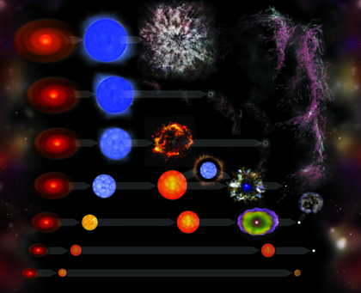

1. N Schneider et al. *A&A* **529** (2011) A1.
2. Zuckerman and Song, *ARAA* **42** (2004) 685
3. http://csep10.phys.utk.edu/astr162/lect/energy/ppchain.html
4. Sparke and Gallagher, *Galaxies in the Universe*, Cambridge University Press 2007 (Chapter 1 figure 4)
5. Lejeune and Schaerer, *A&A* **366** (2001) 538
6. http://moca.monash.edu/research/sins.html
7. Althaus et al, *A&A* **435** (2005) 631.